**Tour Through the Muscular System Lab Sheet:**

**Muscular System**

There are roughly ________ muscles in the human body.

Muscles Are:

* Needed for _______________________
* Needed to ________________________
* Needed to ________________________
* Needed to________________________ ________________________________
* Needed to ________________________ _________________________

**3 Types of Muscle:** Identify each of the types of muscle tissue below:

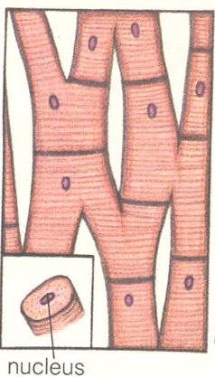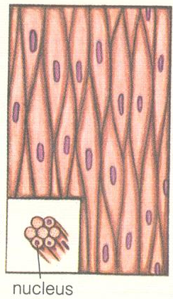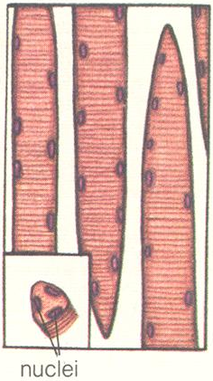

______________ _____________ _____________

**Skeletal Muscle Tissue:**

* Moves your _____________
* Voluntary (______________________________________)
* Over ________________________________ in your body
* Long cells with ________________________________ (along edges of cell)
* Stripes called ___________________ in cell
* **Explain** how to identify this muscle tissue under a microscope:

**Cardiac Muscle Tissue:**

* The muscle of the __________
* Involuntary (_______________ _______________________)
* Works _____________ a day
* Strongest ________________ ________________________
* Only ________________ per cell (usually in ____________)
* Some _____________ (________________)
* **Explain** how to identify this muscle tissue under a microscope:

**Smooth Muscle Tissue:**

* Muscles of the _____________ __________________________________________________
* Involuntary (_______________ _________________________
* Contract _________ and ____________
* Usually _______________ per cell.
* No __________________
* **Explain** how to identify this muscle tissue under a microscope:

**Anatomy of a Muscle**: Label the bone, tendon, myofibril, fascicle, body of muscle, and muscle fiber

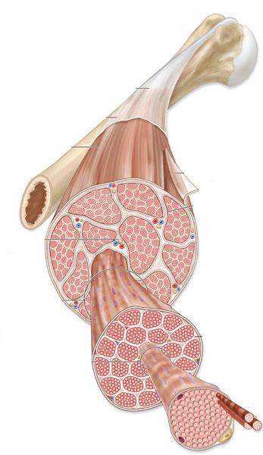

**Opposites Contact and Relax**:

* Muscles work in pairs called ________________________
* The biceps muscle will __________ (___________) the arm at the elbow = ______________________ and the triceps muscle will ________________ (_______________) the arm = _____________________
* While one muscle in the pair _____________ the other must _____________.
* The other opposing groups moves your limbs (like arms and legs) ___________ or ________________ the _______.
* The deltoid muscle will move the arm _________________ the body= ______________ muscle, and the latissimus dorsi will move the arm _______________________ the body= _______________ muscle.

**How a Muscle Works**:

* A skeletal muscle works by ________________.
* Each muscle cell is made up of many smaller ___________
* The ________________ are in contact with a ________________
* Myofibrils are made of two proteins, ___________ and __________
* The __________ and ___________ __________ past ___________________ causing the muscle to ______________.
* Explain, in your own words how muscles contract through actin and myosin filaments sliding past each other:

**Muscle to Tendon to Bone**:

Tendons attach _____________ to _______________

Label the bone, muscle, and tendon in each picture:

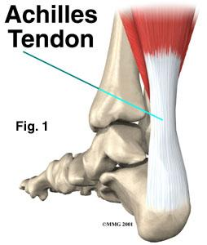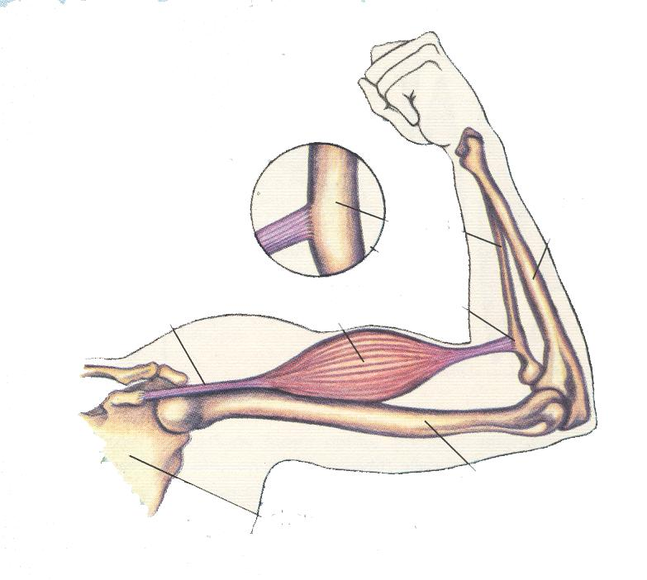

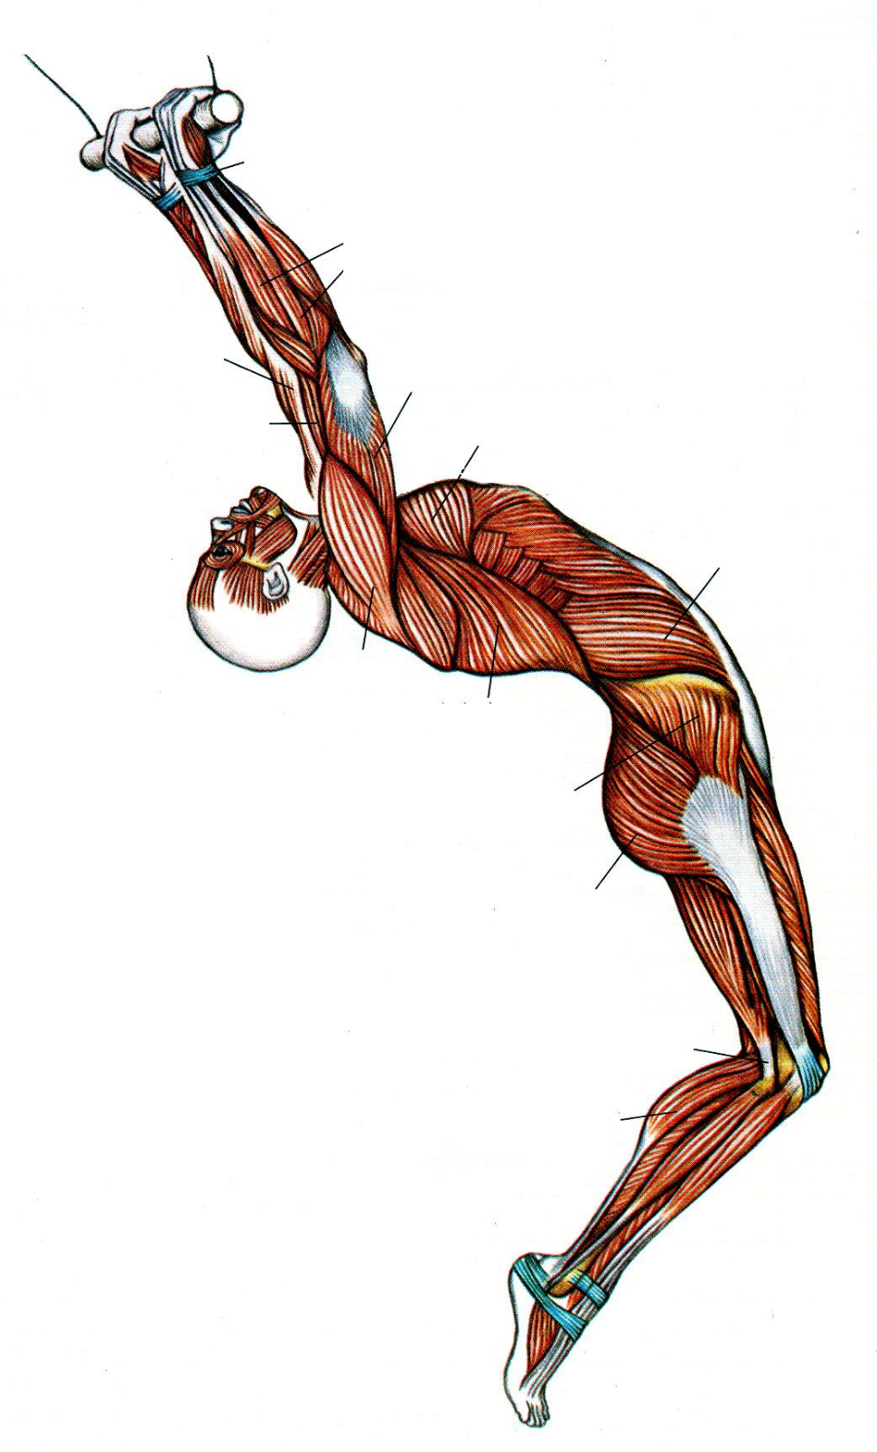

**J**

**I**

**H**

**G**

**F**

**E**

**D**

**C**

**B**

**A**

Using the muscle diagrams in the muscle system tour, identify and label the following muscles. Use this word bank of muscles to help you:

Gluteus maximus

Latissimus dorsi

Pectoralis major

Gastrocnemius

Triceps

Brachioradialis

Deltoid

Biceps

Exterior oblique

Gluteus medius